Unit 3: Design thinking techniques

Design thinking is iterative rather than linear. Tools that promote creativity, match user demands, and improve solutions include empathy maps, HMW questions, SCAMPER, prototyping, and usability testing.
Definition- A tool is anything (physical, digital, or conceptual) that is used to carry out a task, solve a problem, or achieve a specific purpose more effectively. Tools extend human ability, making work easier, faster, or more precise.
Types of Tools
1. Physical Tools- Handheld or mechanical instruments.
Examples: Hammer, screwdriver, scalpel, microscope.
2. Digital Tools- Software, apps, or platforms that aid in tasks.
Examples: Microsoft Excel (data analysis), Google Docs (collaboration), Photoshop (design).
3. Conceptual / Methodological Tools- Frameworks, models, or structured techniques that guide thinking.
Examples: SWOT Analysis, Design Thinking, Mind Maps.
4. Social / Engagement Tools- Methods to connect, motivate, and involve people.
Examples: Surveys, Interviews, Gamification apps.

Characteristics of Tools
Purpose-driven → Designed to achieve a task.
Efficiency-enhancing → Makes work easier/faster.
User-dependent → Needs skill or knowledge to use effectively.
Can be simple or advanced→ From a stone axe to AI-powered platforms.

Based on above understanding Tools can be defined as:
A tool is any aid—physical, digital, or conceptual—that enables humans to perform tasks more effectively.

I. Listening & Empathizing Techniques
Empathize stage of Design Thinking focuses on deeply understanding users. This stage uses listening and empathizing techniques to capture real insights.
1. Engagement- Engagement tools are methods, platforms, or techniques used to capture, maintain, and enhance the attention, participation, and involvement of an audience—whether students, employees, customers, or community members. They can be digital or non-digital, depending on the context.
- Direct interaction with users in their context.
- Builds trust and rapport → users share openly.
- Strength: Reveals emotional drivers and motivations.
Examples: shadowing a user during daily tasks, co-creating with them.

2. Observation- Observation tools are methods and instruments used to systematically watch, record, and analyse behaviours, events, or processes in order to gather insights. They are widely applied in education, research, healthcare, workplace studies, and user experience design.
- Watch users in their natural environment.
- Focus on behaviours, routines, body language rather than only words.
- Tools: field notes, photo/video capture, journey mapping.
Example: Observing how people carry groceries → insights into bag design.

3. Interviews- Interview tools are methods, techniques, and platforms used to plan, conduct, and analyze interviews for data collection, recruitment, research, or feedback. They help ensure interviews are structured, reliable, and insightful.
- One-on-one or group conversations.
- Goal: uncover needs, values, and frustrations.
- Types:
  - Structured (set questions)
  - Semi-structured (flexible, exploratory)
  - Unstructured (open conversations)
Example: Asking patients about their experiences with hospital waiting times.

4. Surveys- Survey tools are platforms, methods, and techniques used to design, distribute, and analyze surveys for collecting data, feedback, or opinions from individuals or groups. They help in research, education, marketing, customer experience, and organizational development.
- Collect data from a large sample quickly.
- Best for: validating patterns seen in interviews/observations.
- Strength: Provides quantitative insights to support qualitative findings.
Example: Measuring how many users prefer home delivery vs. in-store pickup.
II. Define Stage in Design Thinking

A tool is anything (physical, digital, or conceptual) that is used to carry out a task, solve a problem, or achieve a specific purpose more effectively. Tools extend human ability, making work easier, faster, or more precise.
Define techniques create a 360° view of the user → combining what people say, do, think, and feel.
It’s about framing the right problem based on insights.

1. Create Problem Statements
- Frame insights into clear, actionable problem definitions.
- Use the POV (Point of View) statement: [User] needs [need] because [insight].
Example: A busy working mother needs a faster way to plan meals because she struggles with time management.

2. Identify User Needs & Pain Points
- Extract key functional, emotional, and social needs from research.
- Highlight recurring challenges, frustrations, or gaps in current solutions.
Example: Grocery app users need predictable delivery times; pain point = late deliveries.

3. Synthesize Research Data
- Make sense of raw research (interviews, observations, surveys).
- Tools used:
  - Affinity Mapping (grouping insights into themes)
  - Empathy Maps (say, do, think, feel)
  - Journey Maps (touchpoints, emotions, barriers)
- Goal: Translate data into meaningful insights.

4. Reframe the Challenge
- Shift focus from solution-first to problem-first thinking.
- Ask: “How might we…?” (HMW questions) to encourage creativity.
Example: How might we help students manage stress during exams?
The Define stage = clarity → it ensures teams solve the right problem, not just any problem.
III. Ideation Techniques

1. Pattern Recognition
Definition: Spotting recurring trends, behaviours, or relationships in problems or data to generate ideas.
Why it works: Humans are naturally wired to see patterns → helps simplify complex challenges.
How to use:
- Look for repeated problems across users or markets.
- Identify common behaviours in customer journeys.
- Analyse successful solutions in one domain and adapt them to another.
Example:
- Uber recognized the pattern of idle cars + people needing rides → built a shared economy solution.
- Oral-B recognized brushing mistakes (wrong angles, pressure) → designed angled bristles & smart toothbrushes.

2. SCAMPER Technique
Definition: A checklist-based creativity tool to modify existing products, services, or processes.
SCAMPER stands for:
- S – Substitute (materials, processes, people?)
- C – Combine (merge features, ideas?)
- A – Adapt (borrow ideas from other industries?)
- M – Modify/Magnify (change shape, scale, look?)
- P – Put to another use (repurpose product?)
- E – Eliminate (remove unnecessary parts?)
- R – Reverse/Rearrange (change sequence or opposite function?)
Example:
- Airbnb:
  - Substitute hotels → local homes
  - Combine travel + local experiences
  - Adapt e-commerce trust system (reviews) for hospitality
  - Eliminate need for hotel ownership

3. Connecting the Dots
Definition: Innovation emerges when unrelated ideas, experiences, or fields are linked together.
Why it works: Creativity often comes from intersections of knowledge.
How to use:
- Cross-industry thinking: bring solutions from one sector to another.
- Blend technology, design, and user insights.
- Draw from personal experiences + observations.
Example:
- Steve Jobs: Calligraphy class → inspired beautiful typography on Apple computers.
- Big Basket: Connected tech (e-commerce) + daily needs (groceries) → online grocery revolution.
IV. Forms of Prototyping in Design Thinking

1. Paper Prototypes (Low-Fidelity)
- Simple sketches on paper → quick and inexpensive.
- Best for: early testing of ideas, layouts, work flows.
- Pros: Fast, cheap, encourages iteration.
Example: Drawing app screens on sticky notes.

2. Wireframes (Mid-Fidelity)
- Digital or drawn structures showing layout & functionality.
- Focus: structure, hierarchy, navigation flow (not colours/design).
- Tools: Figma, Balsamiq, Adobe XD.
Example: A wireframe of an e-commerce checkout page.

3. Models (Physical Prototypes)
- Tangible versions of products/solutions.
- Best for: hardware, objects, packaging, physical experiences.
- Can be low-fidelity (cardboard, clay) or high-fidelity (3D-printed, working mockups).
Example: Car dashboard prototype with cardboard controls.

4. Role-Play Scenarios (Experiential Prototypes)
- Simulating an experience or service with people acting out roles.
- Focus: interactions, user journey, service flow.
- Best for: Service design, healthcare, hospitality.
Example: Acting out hospital patient admission process.
V. Forms of Testing in Design Thinking

1. Usability Testing
Testing how easily users interact with the prototype/product.
Focus: ease of use, clarity, efficiency, satisfaction.
Methods: observation, task completion, time-to-task, think-aloud.

2. Concept Testing
Evaluating early- stage ideas or concepts before prototyping.
Focus: Does the idea resonate with users?
Methods: storyboards, sketches, value proposition feedback.

3. A/B Testing (Comparative Testing)
Presenting two or more versions of a design to see which works better.
Focus: Identify preferred features, layouts, interactions.
Method: Split users into group’s → compare outcomes.

4. Desirability Testing
Tests emotional connection and user preference.
Focus: Does the design appeal to users?
Methods: card sorting, preference ranking, desirability word lists.

5. Feasibility Testing
Tests whether the solution is technically and practically possible.
Focus: Can we build it with current tech, time, and resources?
Methods: Often run in parallel with usability tests.

6. Viability Testing
Examines if the idea is sustainable for the business.
Focus: Costs, scalability, profitability, and market fit.
Ensures design aligns with business strategy.

7. Prototype Testing (Low–High Fidelity)
Testing different levels of prototypes (paper sketches → clickable models → real products).
Focus: Identify flaws; gather user insights at different fidelity levels.

8. Pilot / Field Testing
Real-world testing with actual users in natural environments.
Focus: How does the solution work in practice?
Method: small-scale launch (beta testing, pilot programs).

Case Study 1: Pure it – Making Safe Drinking Water Affordable

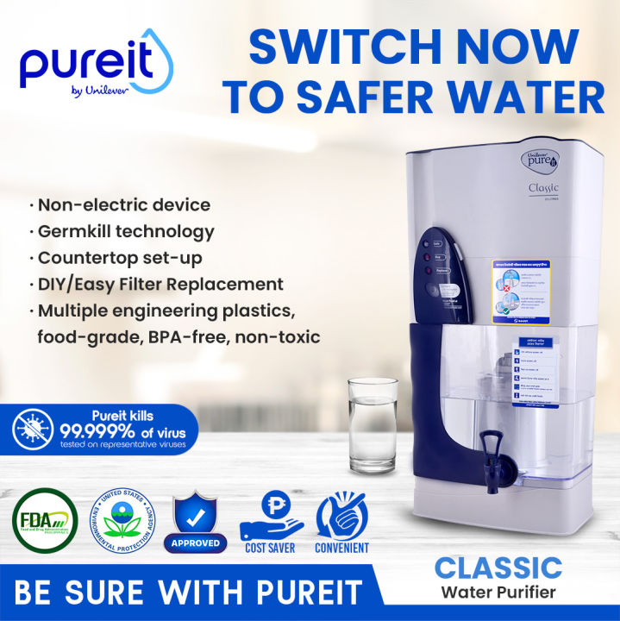

1. Introduction
Pure it, launched by Hindustan Unilever Limited (HUL) in 2004, is one of the world’s most widely used in-home water purifiers. It was designed to provide safe, affordable, and easily accessible drinking water, especially for low and middle-income households in developing countries like India.
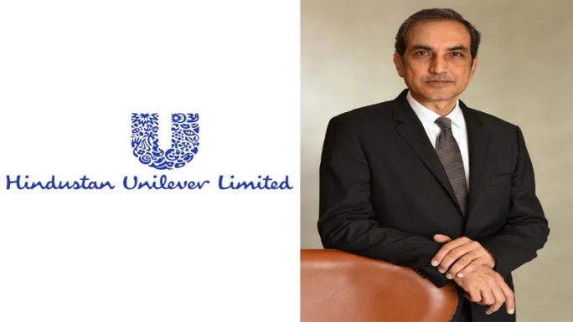 CEO Rohit Jawa
2. Problem Statement
- India faces a severe drinking water challenge:
  - 70% of India’s water is contaminated.
  - Millions suffer from water-borne diseases (diarrhoea, cholera, dysentery).
  - Rural and low-income households lack access to expensive water purification systems (like RO and UV).
- Bottled water and boiling were costly and inconvenient solutions.
- There was a need for an affordable, reliable, and user-friendly solution to purify water at the household level.

3. Solution: Pureit’s Innovation
Pure it introduced “point-of-use” purifiers using unique technology:
- No electricity or running water needed → works anywhere.
- Multi-stage purification (microfibre mesh, carbon trap, germ kill cartridge, and micro-channels).
- Affordable cost → initially priced at ₹1,800 (much lower than RO purifiers).
- Pay-as-you-go cartridge model → only replace the Germkill Kit when water capacity is exhausted.
- WHO standards compliance for safe drinking water.

4. Business Model
- Target audience: Low and middle-income households.
- Distribution channels: Traditional retail, direct selling, and later e-commerce.
- Marketing strategy:
  - Focus on health benefits (“Protect your family from waterborne diseases”).
  - Mass campaigns with demonstrations in rural and urban areas.
  - Microfinance tie-ups for affordability in rural India.
- Brand positioning: “Safe water for all” – an inclusive product.

5. Impact
- Reached millions of households in India and expanded to other countries (Bangladesh, Nigeria, Indonesia, etc.).
- Improved access to safe drinking water for underserved communities.
- Strengthened HUL’s socially responsible image while maintaining profitability.
- Created a new market category of non-electric purifiers.

6. Challenges
- Competition from local and global brands (Kent, Aquaguard, Livpure).
- Shifting consumer preference towards RO + UV purifiers for advanced purification.
- Need for continuous innovation and affordability balance.
- Awareness gap in rural areas despite affordability.

7. Lessons Learned
- Frugal innovation can address critical social issues while being profitable.
- Affordability + Accessibility + Awareness is the key to rural market penetration.
- Social impact and business success can go hand in hand.
- Ongoing R&D and marketing are necessary to sustain leadership in a competitive market.

8. Conclusion
- Pure it successfully democratized access to safe drinking water in India by combining innovation, affordability, and social purpose.
- It stands as a prime example of how multinational corporations can design solutions for emerging markets while making a significant societal impact.

Case Study 2: Royal Enfield – The Revival of an Iconic Brand

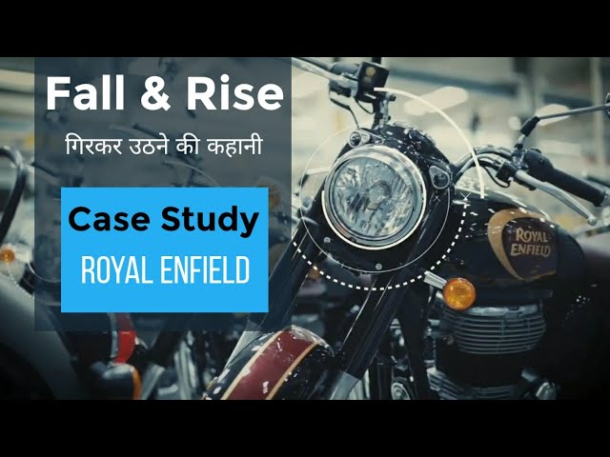

1. Introduction
- Brand: Royal Enfield (originally a British brand, acquired by Eicher Motors in 1994).
- Known for: Classic motorcycles (Bullet, Classic, Thunderbird, Himalayan).
- World’s oldest motorcycle brand in continuous production.
- Today, a cult brand with a global fanbase.
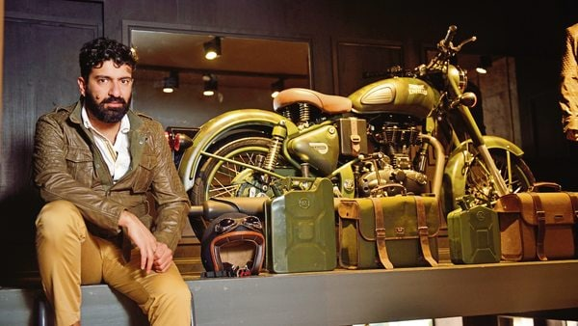 CEO Siddhartha Lal

2. Problem Statement
- By the 1990s, Royal Enfield was on the verge of collapse:
  - Declining sales.
  - Perception: outdated, unreliable, “poor man’s Bullet.”
  - Japanese motorcycles (Hero Honda, Yamaha, Bajaj-Kawasaki) dominated with modern, fuel-efficient bikes.
- Eicher Motors (a tractor/truck manufacturer) faced the challenge:
  - How to revive a dying legacy brand?

3. Strategic Revival
Royal Enfield reinvented itself under CEO Siddhartha Lal:
- Focused Strategy
  - Divested other businesses → concentrated solely on motorcycles.
- Product Innovation
  - Revamped Bullet, introduced Classic 350/500 (retro + modern reliability).
  - Launched new models like Himalayan (adventure) and Interceptor 650 (global twin-cylinder bike).
- Brand Positioning
  - Positioned as a lifestyle brand (not just transport).
  - Emotional appeal: “Made like a Gun, Goes like a Bullet.”
  - Targeted urban youth aspiring for adventure, individuality, and nostalgia.
- Community Building
  - Created Rider Clubs & events (e.g., Rider Mania, Himalayan Odyssey).
  - Promoted biking culture → made Royal Enfield a social identity.
- Global Expansion
  - Export focus (Europe, US, LATAM).
  - Set up technology centers in UK & India.

4. Impact
- Sales skyrocketed from ~20,000 bikes/year in early 2000s to over 8 lakh/year by 2019.
- Became India’s market leader in the mid-size motorcycle segment (250cc–750cc).
- Cult following among millennials & global biking enthusiasts.
- Transformed from a failing brand to a premium aspirational lifestyle company.

5. Challenges
- Increasing competition (Jawa, Yezdi, Benelli, Honda H’ness, Bajaj-Triumph).
- Shift to EVs → How to retain “thump” identity in electric mobility?
- Quality concerns occasionally affect reputation.
- Need to continuously innovate while preserving heritage.

6. Lessons Learned
- Focus is power: Divesting distractions saved Royal Enfield.
- Emotional branding builds loyalty beyond product features.
- Community marketing creates lifestyle brands, not just commodities.
- Revival of legacy brands requires balancing heritage + modernity.

7. Conclusion
Royal Enfield’s journey is a classic turnaround story: from near-extinction to becoming a global cult brand. Its success lies in frugal innovation, powerful brand storytelling, and lifestyle positioning. Today, it stands not just as a motorcycle manufacturer but as a symbol of freedom, adventure, and individuality.

Case Study 3: Big Basket – Revolutionizing Online Grocery in India

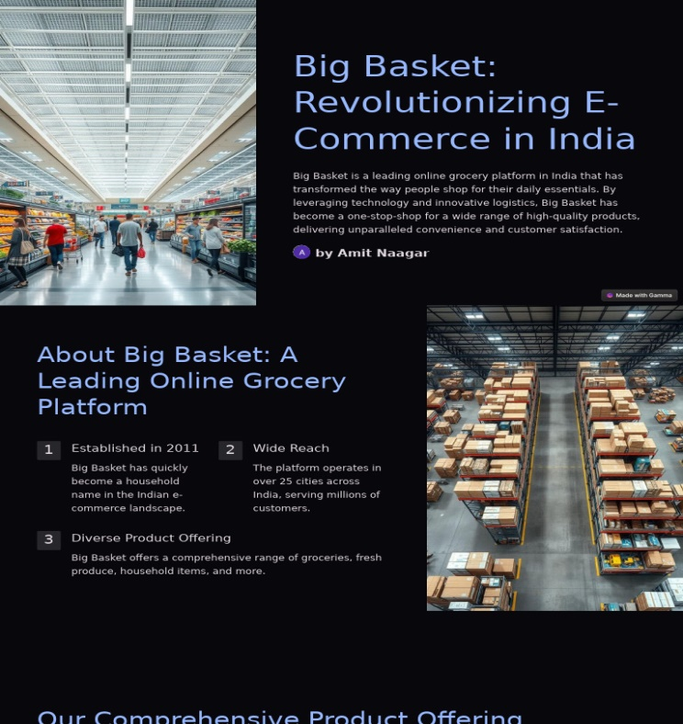

1. Introduction
- Founded: 2011, Bangalore by Hari Menon & team.
- Business: Online grocery delivery platform.
- Backed by Tata Group (majority stake acquired in 2021).
- Product range: Over 20,000+ products across categories.
- Present in 300+ cities.

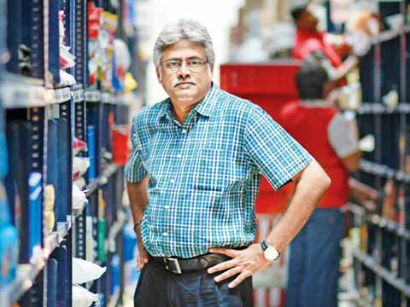 CEO Hari Menon

2. Problem Statement
- Traditional grocery shopping in India:
  - Fragmented retail (kirana stores).
  - Long queues, limited variety.
  - Inconsistent product quality.
- Customers wanted convenience + reliability.
- Challenge: How to make Indians comfortable buying groceries online?

3. Business Model
- B2C Online Marketplace: Website + Mobile App.
- Inventory Model: Own warehouses + dark stores for efficiency.
- Hybrid Sourcing: Direct from farmers, brands, distributors.
- Delivery Models:
  - Express (within hours).
  - Slot-based delivery.
  - BB Daily (subscription for milk/essentials).

4. Strategy for Growth
- Customer-Centric Approach
  - Wide product selection (fresh produce + packaged goods).
  - Strict quality control.
  - Convenient delivery slots.
- Technology & Data Analytics
  - Demand forecasting, route optimization.
  - Personalized offers & recommendations.
- Partnerships
  - Tie-ups with local farmers & FMCG brands.
  - Tata Digital acquisition → stronger backing.
- Brand Positioning
  - “India’s largest online supermarket.”
  - Marketing campaigns like “No queue, BigBasket”.

5. Impact
- Grew to 15 million+ customers.
- Market share: 30%+ in India’s online grocery segment.
- Revolutionized how urban Indians shop for groceries.
- Empowered farmers through direct procurement.
- Boosted consumer trust in e-grocery as a category.

6. Challenges
- Unit economics: Thin margins in grocery retail.
- Competition: Grofers (Blinkit), Amazon Pantry, JioMart, Swiggy Instamart, Zepto.
- Logistics complexity: Delivering fresh produce on time.
- Customer retention in a highly competitive market.

7. Lessons Learned
- Convenience + Trust = Success in e-grocery.
- Hybrid model (inventory + marketplace) ensures efficiency.
- Customer loyalty comes from reliability, not discounts alone.
- Strategic partnerships (like Tata) are crucial for scaling.

8. Conclusion
Big Basket transformed grocery shopping in India by solving pain points of convenience, quality, and variety.
Its journey highlights how tech-enabled models, strong supply chains, and customer trust can disrupt even the most traditional sectors.

Case Study 4: IDEO Water Pump – Human-Centered Design for Social Impact
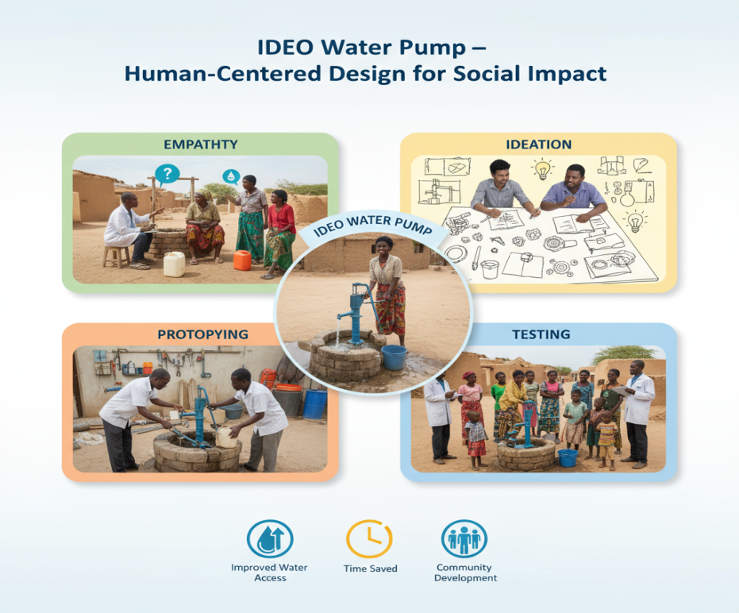

1. Introduction
- Company: IDEO (global design & innovation consultancy).
- Project: Affordable water pump for rural communities.
- Context: Many rural families in developing countries lacked reliable irrigation tools.
- Traditional pumps were expensive, hard to maintain, or not suitable for small farmers.

2. Problem Statement
- Small farmers struggled with:
  - Lack of access to affordable irrigation technology.
  - Heavy reliance on rainfall → poor crop yields.
  - Expensive mechanized pumps were unaffordable.
  - Poverty cycle continued due to low productivity.
- Challenge: Design a low-cost, user-friendly irrigation pump for rural farmers.

3. Design Approach
IDEO applied Human-Centered Design (HCD) principles:
- Understand Users – Engaged with farmers in East Africa & Asia.
- Constraints Focused – Must be affordable, durable, simple.
- Prototyping – Multiple iterations with real farmer feedback.
- Co-Creation – Farmers tested and refined designs.

4. The Solution
- Developed the “MoneyMaker” Treadle Pump (for IDE in collaboration with KickStart).
- Features:
  - Foot-operated, human-powered.
  - Affordable (fraction of engine pump cost).
  - Portable and easy to repair locally.
  - Increased water access for irrigation → higher yields.

5. Business Model
- Not just a product, but a social enterprise model:
  - Distributed through local vendors.
  - Marketed directly to farmers (demonstrations in villages).
  - Farmers bought pumps as income-generating tools, not charity.
  - Scalable, replicable model.

6. Impact
- Over 250,000 pumps sold (Africa & Asia).
- Enabled small farmers to irrigate land year-round.
- Helped lift millions out of poverty by increasing crop yields & incomes.
- Recognized globally as a design-for-impact success story.

7. Challenges
- Distribution in remote rural areas.
- Initial resistance from farmers (affordability concerns).
- Training & awareness needed for adoption.
- Scalability beyond pilot regions.

8. Lessons Learned
- Human-Centered Design is key to solving real-world problems.
- Affordability + usability drive adoption in rural markets.
- Social innovation can be sustainable & profitable.
- Partnerships (NGOs, local vendors, microfinance) ensure scale.

9. Conclusion
IDEO’s water pump project demonstrates how design thinking can empower communities by addressing fundamental needs.
It’s a prime example of how innovation + empathy + sustainability can transform lives and create lasting social impact.

Case Study 5: Airbnb – Disrupting the Hospitality Industry
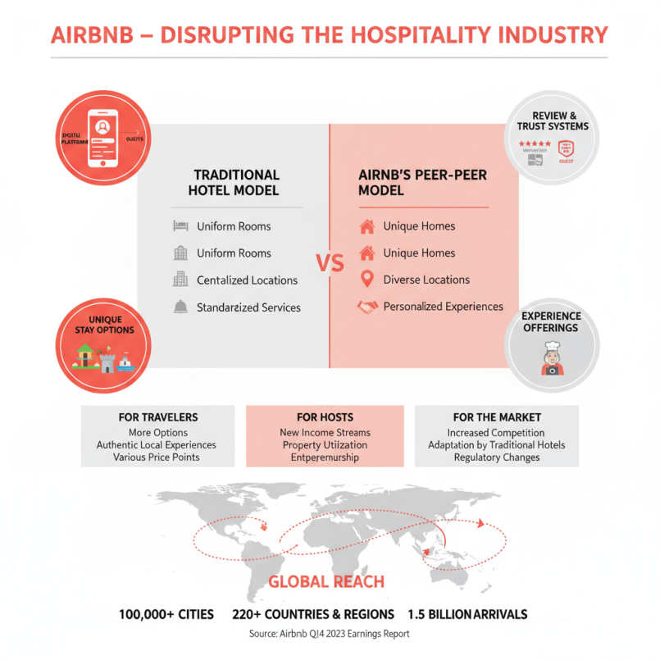

1. Introduction
- Founded: 2008, San Francisco by Brian Chesky, Joe Gebbia, Nathan Blecharczyk.
- Platform: Online marketplace for short-term rentals & experiences.
- Tagline: “Belong Anywhere.”
- Present in 190+ countries, 7M+ listings.
- Valued at over $100B (as of IPO 2020).

2. Problem Statement
- Hotels were expensive & limited in availability during peak seasons.
- Travelers lacked affordable, local, and authentic stay options.
- Homeowners had unused spaces but no easy way to monetize them.
- Challenge: Create a trusted platform to connect hosts & travelers.

3. Business Model
- Peer-to-peer marketplace: connects hosts & guests.
- Revenue: Commission-based model
  - ~3% from hosts.
  - 6–12% from guests.
- Value Proposition:
  - For guests → Affordable, unique, local stays.
  - For hosts → Extra income from unused property.

4. Strategy for Growth
- Design Thinking & UX – Simple, user-friendly platform.
- Trust & Safety – Reviews, ratings, secure payments, insurance for hosts.
- Experiential Travel – Airbnb Experiences (tours, activities).
- Branding – Focus on belonging, community, “live like a local.”
- Global Expansion – Aggressive growth in cities worldwide.

5. Impact
- Revolutionized global hospitality → hotels face major disruption.
- Enabled millions of homeowners to earn income.
- Expanded to Airbnb Luxe, Airbnb Experiences, and long-term stays.
- Symbol of the sharing economy model.

6. Challenges
- Regulatory issues: Many cities restrict short-term rentals.
- Safety concerns: Incidents impacting trust.
- Competition: Booking.com, Vrbo, OYO, traditional hotels.
- COVID-19 impact (2020): Travel demand collapsed.

7. Lessons Learned
- Trust is critical in peer-to-peer marketplaces.
- Disruption comes from matching unused assets with unmet demand.
- Strong brand storytelling builds global loyalty.
- Agility is essential → Airbnb pivoted to longer stays during COVID.

8. Conclusion
Airbnb transformed hospitality by democratizing travel and creating a global community-driven platform.
Its success lies in blending technology, trust, and human connection, making it one of the most iconic startups of the 21st century.

Case Study 6: Oral-B – Redefining Oral Care through Innovation

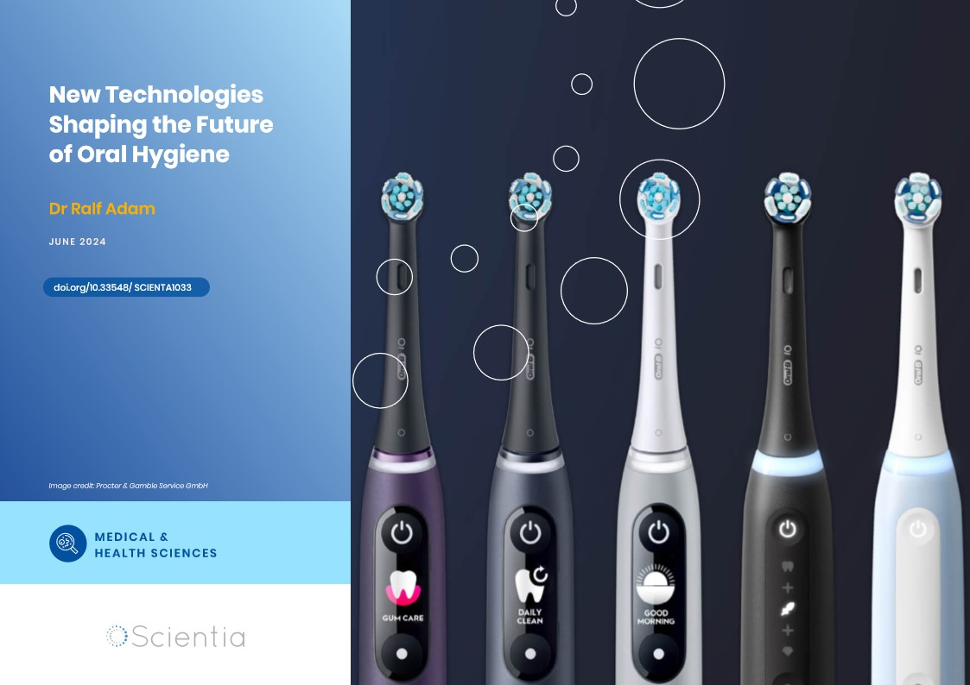

1. Introduction
- Brand: Oral-B (owned by Procter & Gamble).
- Category: Oral hygiene products – toothbrushes, toothpaste, floss.
- Known for: Dentist-recommended toothbrush brand worldwide.
- Focus: Innovation in oral care technology and professional endorsement.

2. Problem Statement
- Traditional manual toothbrushes lacked differentiation.
- Consumers unaware of proper brushing techniques & oral hygiene needs.
- Growing competition from Colgate, Pepsodent, and Sensodyne.
- Market needed scientifically designed, dentist-approved products.

3. Innovation & Solution
Oral-B revolutionized the toothbrush category through R&D + dentist collaboration:
- Ergonomic Design: Angled bristles (Cross Action), gum care tips.
- Electric Toothbrushes: Introduced in 1960s, enhanced in 2000s.
- Smart Toothbrushes: Bluetooth-enabled brushes with AI (Oral-B Genius, iO series).
- Specialized Products: Kids’ brushes, sensitive teeth variants, plaque-removing bristles.
- Professional Endorsement: Strong association with dental community.

4. Business Strategy
- Differentiation through technology (not just commodity product).
- Heavy investment in clinical research & patents.
- Dentist partnerships: positioned as “Dentist-recommended brand.”
- Global marketing with health + lifestyle focus.
- Wide portfolio → manual + electric + premium smart brushes.

5. Impact
- Oral-B became the #1 dentist-recommended brand globally.
- Increased consumer awareness of oral hygiene.
- Electric & smart toothbrushes created a premium oral care segment.
- Strong brand loyalty and global market leadership in oral care.

6. Challenges
- High competition from Colgate (toothpaste-driven loyalty).
- Affordability gap for electric/smart brushes in emerging markets.
- Counterfeit and generic low-cost brushes in local markets.
- Need to constantly educate consumers about product benefits.

7. Lessons Learned
- Innovation + science can transform even a simple product category.
- Professional endorsement builds long-term trust & credibility.
- Premiumization works when paired with education & awareness.
- Continuous innovation is essential in FMCG to stay ahead of competition.

8. Conclusion
Oral-B changed the toothbrush from a commodity to a medical device that is based on science. Oral-B maintains its innovative and trustworthy leadership in the global oral care market by fusing research and development, dentist collaborations, and consumer education.

